Exercise 1: Verifying and configuring setup

Goal: In this exercise, you will adjust the configuration of the project so that it works with your physical setup.
- Open EPICS.lvproj in the EPICS Training\Exercises directory. The project should look like the Project Explorer view shown in Figure 1. 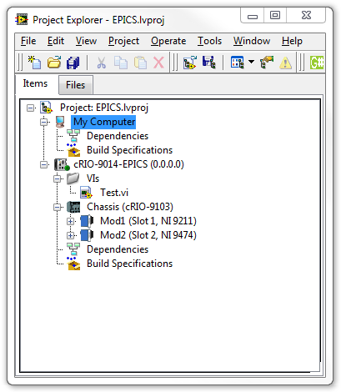
Figure 1. Project Explorer view of EPICS.lvproj

- Right-click on the cRIO-9014 EPICS controller and select Properties. Under the General category, set the IP Address to the IP Address of the system you are targeting.
- Expand the chassis item labeled Chassis and verify that the modules and slots match the modules and slots of your setup
- Label the channel of your setup measuring temperature Temp. For example if the temperature is being measured on AI1. Expand the module item labeled Mod1 and rename AI1 to Temp.
- Similarly modify the names under Mod2 match your setup. Heat is on DO0 and Cool is on DO1.

- Expand the VIs folder and open Test.vi. Look at the block diagram and verify that the variables are linked and relink as necessary. Save the VI if you made changes.
- Run the VI and verify that you can measure temperature, turn on and off the light (heater), and turn on and off the fan (cooler).
- Stop, close, and save the VI.
- From the menu bar of the Project Explorer window select File » Save All (this Project). Leave the project window open for later.

End of Exercise 1

Exercise 2: Setup a simple temperature control VI

Goal: In this exercise, you will setup a simple temperature controller to be used in later exercises.
- Open EPICS.lvproj in the EPICS Training\Exercises directory if not already open.
Note that Exercise 1 must be completed before doing this exercise.
- Under cRIO-9014-EPICS, right-click on the VIs folder and select Add » File. Locate the EPICS Training\Exercises\VIs directory and select Control.vi and click Add File. The front panel of the VI is shown in Figure 2. 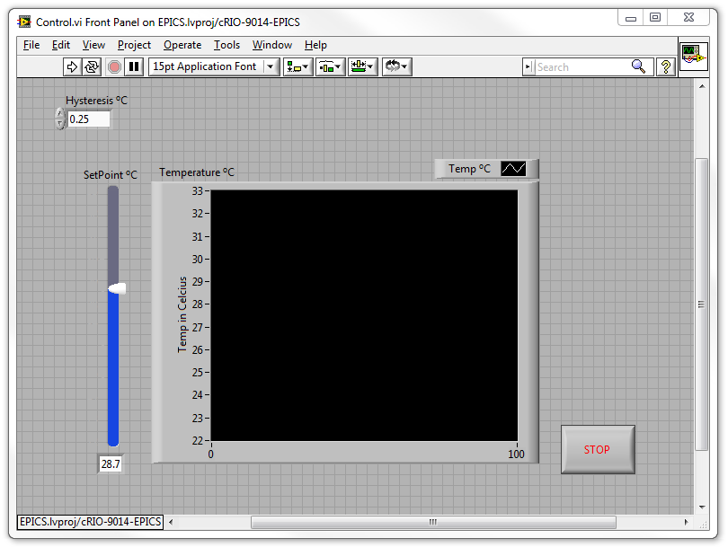
Figure 2. Front Panel of Control.vi

To automate the temperature control we will create a simple control algorithm to turn on the light if the temperature is below a setpoint and to turn on the fan if the temperature is above the setpoint. We will also have a hysteresis or “dead band” so that the light or fan doesn’t turn on if the temperature is “close to” the setpoint.
- Update the block diagram so that is looks like Figure 3. Remember that you can drag and drop the I/O Nodes like Temp directly from the Project Explorer window to the block diagram. To change the direction of a Shared Variable, right-click on the variable and select Access Mode » Read or Write. 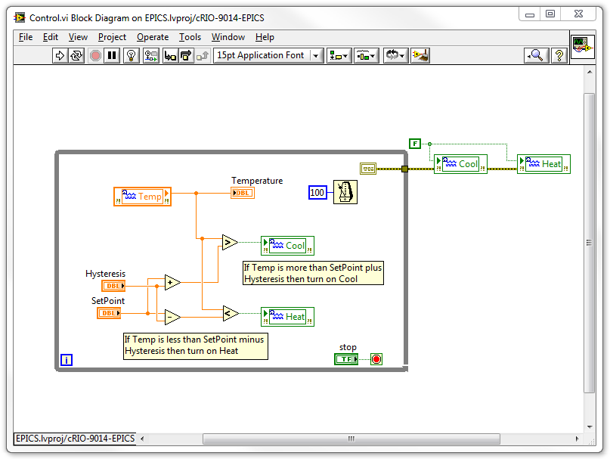
Figure 3. Block diagram of Control.vi

- Run the VI and verify that the temperature moves, if slowly, toward the setpoint. Once near the setpoint, it is normal for the fan or light to turn on and off to keep the value near the setpoint.
- Stop, close, and save the VI.
- From the menu bar of the Project Explorer window select File » Save All (this Project). Leave the project window open for later.

Challenge Exercises
- Add indicators for when Heat and Cool are on.
- Add cursers to the graph to show the location of the setpoint.
- Add a light to indicate when the temperature is within the hysteresis of the setpoint.
End of Exercise 2

Exercise 3: EPICS IOC on cRIO

Goal: In this exercise, you will create and deploy a native EPICS IOC onto cRIO.
Look at and Modify DB file
- Open the sm.db file in the EPICS Training\Exercises\IOC on cRIO\cRIO files\lv-epics\epicsTests\db directory by right-clicking it and selecting Open » Open With » Notepad. It should look like Figure 15. 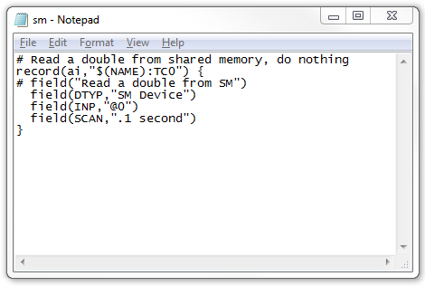
Figure 15. sm.db open in Notepad

- Add the following text to the file:
field(HIGH, 28.0)
field(HIHI, 30.0)
field(LOW, 26.0)
field(LOLO, 24.0)
field(HHSV, MAJOR)
field(HSV, MINOR)
field(LSV, MINOR)
field(LLSV, MAJOR)
field(PREC, 1)
field(EGU, DegC)

Note that the first four fields are the alarm levels, then next four are the severity of those alarms, and the last two are precision and Engineering Units respectively.
- The file should look like Figure 16. 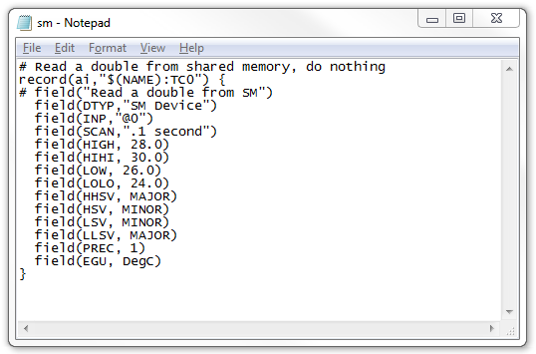
Figure 16. sm.db after modification open in Notepad
- Save and close the file.
Note that the $(NAME) is used for substitution at runtime. In the example we have substituted TEST.

Modify the Bootline to call the startup file (if not already completed for you)
- Flip the cRIO DIP switch to safe mode and make sure the 'console out' DIP switch is on
- Plug a null-modem serial cable into the cRIO serial port and attach the other end to your host.
- Launch Hyperterminal ( Hyperterminal configuration: use COM1, baud rate of 9600, and flow control set to ‘None’)
- Reboot the controller
- Quickly press a key in Hyperterminal 'to stop auto-boot' when the controller is booting up. This will give you a prompt like '[cRIO-901x Boot]:'

- In Hypeterminal, type 'c'
- Type 'enter' to skip past most of the info here, until you get to the 'startup script (s)' field
- Type '/c/startup' (without the quotes)

- Type 'enter' until you are done
- Now flip the cRIO DIP switch out of safe mode

Setup cRIO to run EPICS IOC locally
- Open up Measurement and Automation Explorer (MAX) and locate the controller by expanding Remote Systems.
- Expand the controller, right-click on Software and select Add/Remove Software.
- In the “LabVIEW Real-Time Software Wizard” select NI-RIO 4.0 – August 2011 under LabVIEW Real-Time 11.0 and click Next.
- Under Protocols and Buses, make sure EPICS Client I/O Server 11.0.0 and EPICS Server I/O Server 1.8.0 are both unselected.
- Click Next and Next again to make the changes.
- Click Finish once it completes.
- Locate the controller again in MAX, right-click on the controller and select File Transfer.
- Copy the lv-epics directory and the startup file from the “EPICS Training\Exercises\IOC on cRIO\cRIO files” directory to the “root” (/) directory of the cRIO by selecting the file in the Current Local Directory section, showing the desired location in the Current Remote Directory, and clicking the To Remote button.
- Copy the sm.out, vxnfs.out, vxrpc.out and vxsntpc.out files from the “EPICS Training\Exercises\IOC on cRIO\cRIO files” directory to the “/ni-rt/system/” directory on the cRIO.
- Reboot the cRIO controller.
Modify Control.vi to talk to shared memory
- Close all open projects.
- Open “EPICS IOC.lvproj” in the “EPICS Training\Exercises\IOC on cRIO” directory.
- The project will look like it did after completing exercise 2. You may need to redo the steps from exercise 1 to connect to the hardware.
- Right-click on cRIO-9014-EPICS controller and select Add » Folder (Auto Populating) then display the contents of the “EPICS Training\Exercises\IOC on cRIO\EPICS Library” directory and click Current Folder.
- Expand the VIs folder and open Control.vi.
- Drag and drop the EPICS_SM Write Value.vi from the EPICS Library folder to the VI and wire in the temperature as shown in Figure 17. 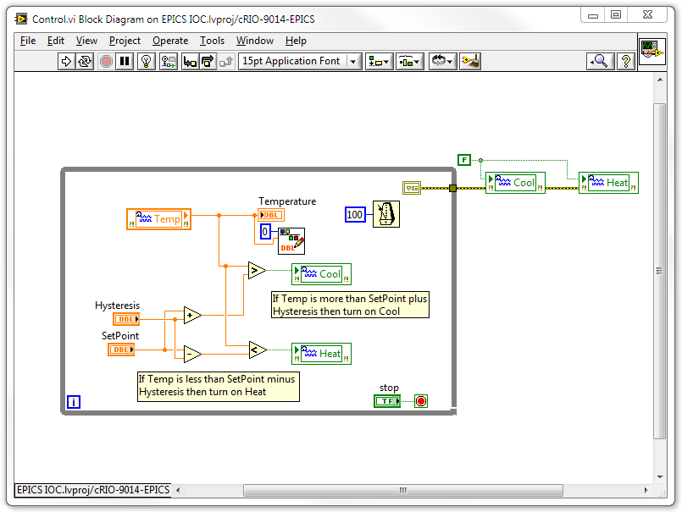
Figure 17. Block Diagram of Control.vi

- Open the command prompt by typing “cmd” (without the quotes) in the Start Menu.
- Type the following:
cd “c:\Program Files\EPICS Windows Tools” (to change directory)
camonitor TEST:TC0
The command window should look like Figure 18. 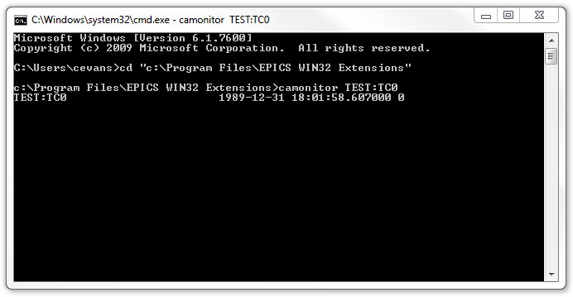
Figure 18. Command Window showing output of camonitor

- Watch the Command Window and run Control.vi. Once Control.vi starts running, you should see updates begin to show on the Command Window similar to Figure 19. 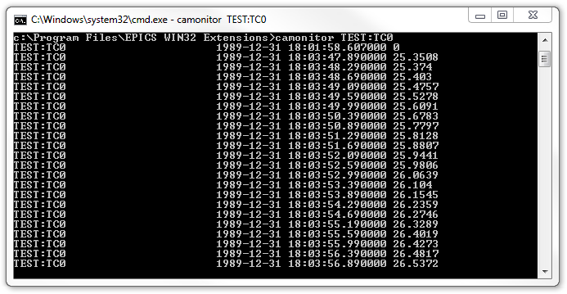
Figure 19. Command Window showing new output of camonitor

- Use TEST:TC0.STAT to read the alarm state and TEST:TC0.SEVR to read the alarm severity. The output will look like Figure 20. 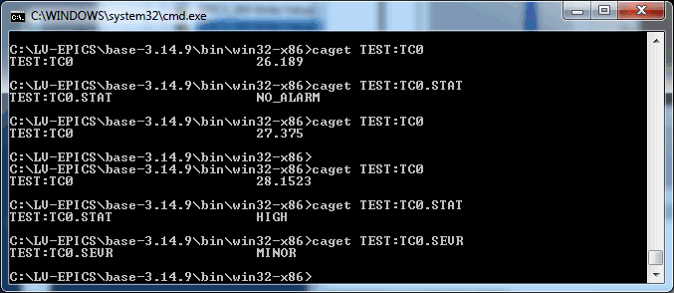
Figure 20. Command Window showing severity and status

- Close and save all open windows.

Challenge Exercise

- Add an Analog Output record to the sm.db file and changes the Control.vi to enable setting the setpoint through an EPICS client.
- Use stripChart or Probe from the EPICS Windows Tools to monitor the PV.

End of Exercise 6

